Path Day 1 Class Assignment

Note: Exercise 2.2 is used from the book.

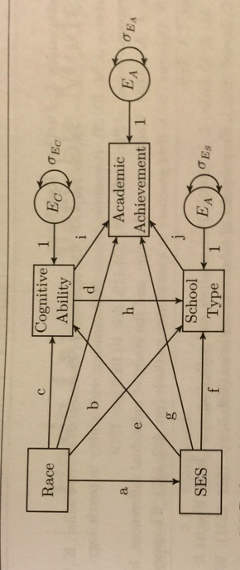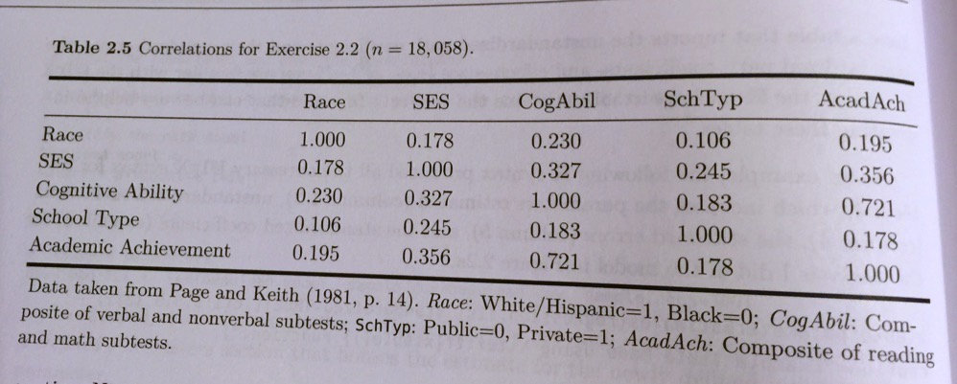

Import the correlation matrix into R.

Create the path model in lavaan – you do not have to label the parameters a, b, c, etc.

Run the model.

Include a picture with the unstandardized estimates.

Note: Exercise 2.3 is used from the book.

Import the covariance matrix into R.

Create the path model in lavaan with the indirect effect.

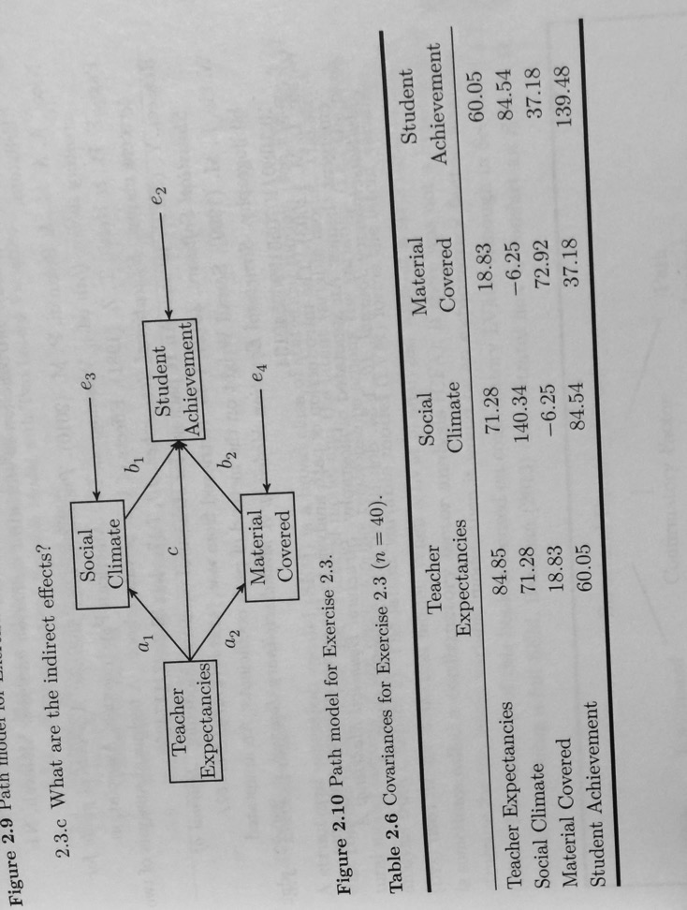Run the model.

Include a picture with the unstandardized estimates.